**Technocraft Industries**

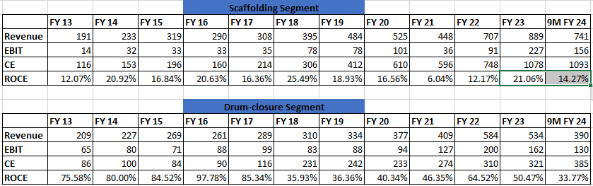

* Scaffolding Business: Healthy growth (~16% over last 10 years) and decent ROCE (although volatile). However despite the volatility, very good long-term growth in profitability while maintaining healthy ROCE.
* Drum-closure Business: Slow growth (~9% over last 10) but very good ROCE (much higher than scaffolding business). Currently going through a difficult period (Europe is the main market; disruption due to Russia-Ukraine war).
* Yarn Business: Has been making losses and pulling down the overall ROCE profile. Demerger of the textile business has been talked about for many years – may or may not happen. However, the replacement of yarn mill would mean this segment could break-even. Also some signs of improving yarn realizations.
* New Aluminium Formwork + Extrusion Business: Seems promising – big expansion, very high ROCE & tailwind from the infrastructure cycle.
* Considering a situation where the headwinds in the drum-closure business persists + textile business stops making losses (but demerger doesn’t happen) + new capacity (Aluminium extrusion + formwork) ramps up, management expects earnings to double from current levels (translate to ~Rs. 500-550 cr). However, this would also be accompanied by incrementally higher ROCEs?
* This boring company may then start getting attention from institutional investors (negligible FII holding)?